Circuit Newsletter 4th Quarter 2024
South Holland Methodist Circuit
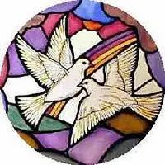

Superintendent Minister - Reverend Luke Smith PG. Dip. TH
Contact email: luke.smith@methodist.org.uk Tel: 07376 248147 / 01406 704489
Circuit Administrator – Sally Gale

Contact email: office@shollandmethodist.org.uk Tel: 07729 137555

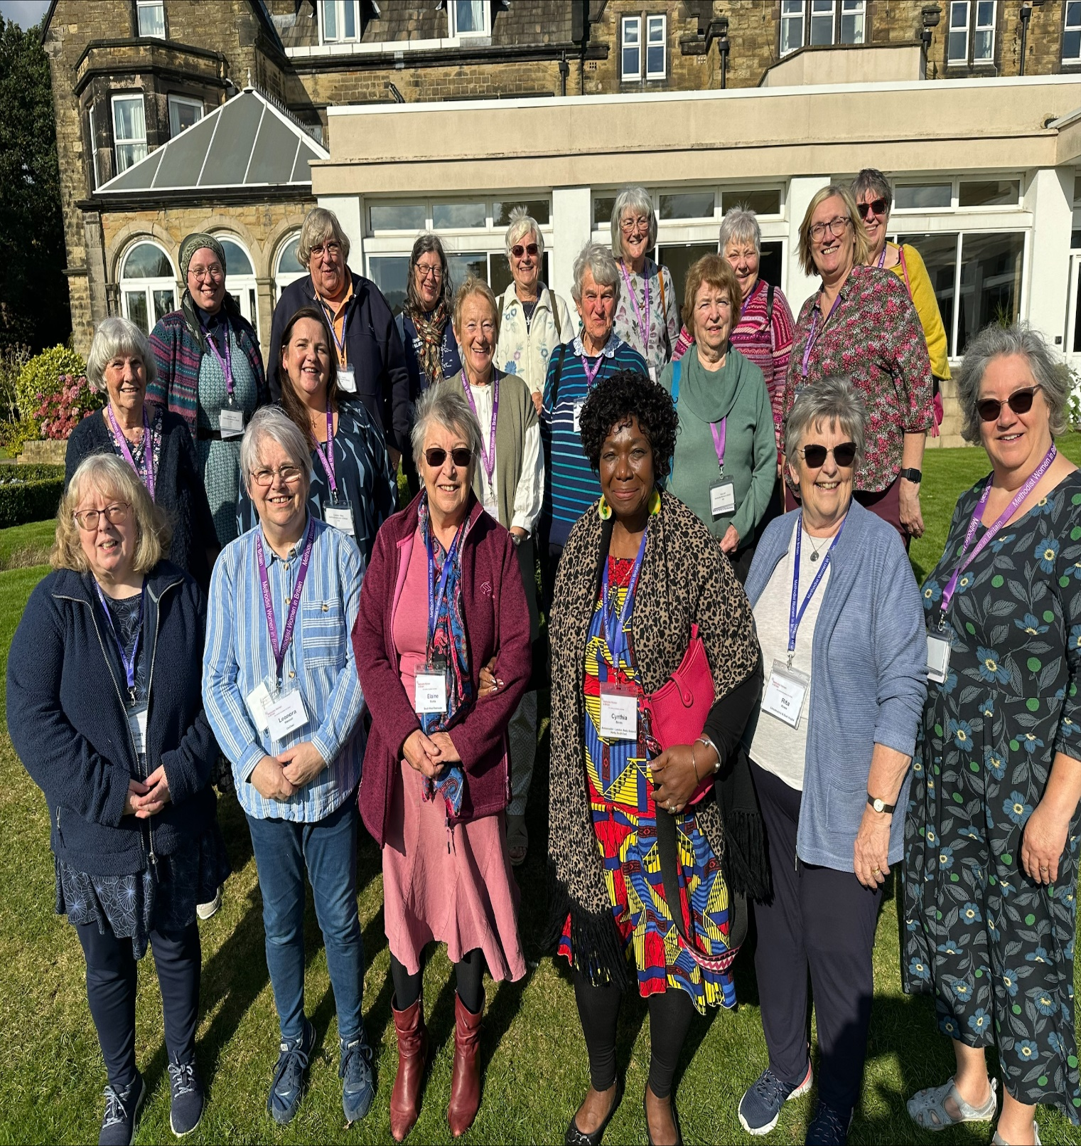



My Busy October with MWiB by Rita Rowe
As all of you know by now I am the Methodist Women in Britain Rep for South Holland Circuit. I am also the Lincolnshire District Secretary and the Trustee for Lincolnshire & East Anglia Areas.
As you all know these two Areas are very big on their own but put them together and they are HUGE. Most Districts like to have 3 “District Days” per year so I get to travel around the pretty countryside of both in the Spring, Summer and Autumn. Three very pretty seasons to watch the landscapes change and the scenery differ in so many ways. Part of my days out are enlightened by the journeys I make to arrive at the destination chosen to host the events. Sometimes I am alone and sometimes I get to enjoy company of other ladies while driving but every time I go I never fail to be amazed at the wonderful sight of God’s Creation in these two Counties, No two journeys are ever the same. It would be good to see more of you at these events and join me in finding out more about MWiB. We are not an exclusive Club……..we are Women who belong to a Methodist Church and now we even have Men accompany us because they are drivers for the Women who cannot drive but love to attend these wonderful days out so I thought I should give you a taste of some of the recent ones I have attended.
I started October by going to Swanwick Conference Centre in Derbyshire 4-6th October for a Trustee Meeting. Trustees comprise of a person from all over England, Scotland and Wales representing their Counties they are “Trustees” for the Counties they represent. Also the Meeting is led by our TWO Co-Chairs, Treasurer, and Communications Officer. We also have a young lady on the Executive who is our Helen Kim Memorial Scholar who is in position for 5 years and gets to travel and represent UK at events all around the World. So far she has been to Ireland, Portugal and even Cornwall meeting other young Women in her position. There was 20 of us altogether for this weekend which we looked at business matters and ideas for the forthcoming year ahead. One of our Co-Chairs (used to be called President and Vice President) has some very good ideas and is very enthusiastic about the MWiB Organisation and has made some wonderful items to promote us. Book marks showing what we do, A pack of prayer cards which can be used for people’s own devotional time or help with Own Arrangement Services and a labyrinth butterfly to embroider for those talented Women who love sewing. The butterfly is our Logo so appropriate for MWiB. The Co-chairs will attend District Days and love getting to know the Areas we Trustees Represent. We all enjoyed a lovely weekend of business, social and relaxation in the gardens of Swanwick because the weather was very kind to us.
On Saturday 12th October I attended the Fund Raiser morning at Broad Street Methodist Church in our very own Circuit. This Church is a very good supporter of MWiB and “Midweekers Group” always promote our events for which I am really grateful for. The morning raised nearly £250 which was incredible as there were only a few stalls comprising of Cakes, Bring and Buy and Raffle and then of course the wonderful Refreshments served in the Hall. It happened to be the Pumpkin festival weekend in Spalding and I do believe we had lots of visitors enjoying the refreshments which contributed to the funds. Well done Broad Street ladies and a Big thank you for doing this every year to help MWiB survive. I also had a stall selling Resources for MWiB which are items like …….note books, shopping bags, notelets, pens, scarves……….lots of things that make good presents if you are lost for ideas. Speak to me if any of these appeal to you!!!!
On Thursday 17th October we held our Lincs District Day at St. Giles Methodist Church, Lincoln and our speaker for the day was Rev. Juliet Wriglesworth and we looked at the story of the Prodigal Son and she had a wonderful painting for us to observe and discuss. A wonderful way of looking at a familiar bible story but in a totally different way. We had a brilliant social time with 28 women from all over the District attending and enjoying lunch together as well as learning and being inspired by people’s stories. We all have a story to tell and it is amazing how some Women have done so many things in their lives that we don’t know about until we talk to one another. Please look out for our future District days and come along to see what we are all about. Our Spring one is in Holbeach so not far for you to travel on March 27th and our speaker is Rev. Vivienne Smith………….more details nearer the time.
On Saturday 19th October I travelled to Stamford for the National (MWiB Day) with another friend from the Circuit so had company on my journey and we had another wonderful time listening to a lovely speaker explaining how we can feel free to express ourselves in worship time with actions as well as words. We enjoyed a hot lunch cooked and served by the volunteers in Stamford who make marvellous meals out of donated food from supermarkets and then serve to people in the community and ask them to pay what they feel is what they can afford. There was a 3 course meal for us if we wanted it or you could choose whichever course you fancied so it was lovely to eat and not have to prepare and cook ourselves. I think there was 40 people that had travelled from all over to join in this event. It was organized by the World Federation of Methodist & Uniting Church Women (WFMUCW) as it was the anniversary weekend. It was a shame it clashed with our Circuit Awayday but it was a very enjoyable day.
The last event for the month was Saturday 26th October when I attended the East Anglia District day held in Histon, Cambridgeshire. I met our Co-chair at Peterborough Railway Station at 9am after she had caught the 6.30 am train from Harrogate to join us and we travelled on together and arrived at 10.10 am. The day consisted of a speaker in the morning who was Rev. Jenny Pathmarajah (from the Histon Circuit) who spoke about Music through the Generations which was quite comical and thought provoking and reminders of our Youth!!!! In the afternoon we had a speaker from an organization called PSP (Progressive Supranuclear Palsy) which is the charity their President is raising funds for over the next year as one of their members has this condition and it is not heard of very much but is also misdiagnosed because it is similar to many other conditions so hard to recognise at the beginning. Another brilliant day out and I left our Co-chair at Peterborough for her journey home at 5 pm after learning a lot about each other during our car journey together.
As you will see it was a very busy and fun-filled October and that was without all my other duties for Church and Circuit. MWiB has so much to offer and if you visit our website www.mwib.org.uk you will find out a lot more about us. We help Countries abroad, as well as local and national needs and have a Grant system called “Social and Community Grant” which might be useful for some Churches.


BICKER NEWS

UPCOMING EVENTS

Sunday 24th November – Church Anniversary 3pm Followed by tea.

Wednesday 27th November – Last coffee morning in 2024 10am-noon.

Sunday 15th December – Carol Service 3pm Followed by mince pies and hot drinks.

Tuesday 24th December – Communion Service 3pm (Christmas Eve)



GOSBERTON NEWS
Since our last newsletter we have continued to serve the local community to the best of our ability.
At our recent Harvest, our congregation worked hard in decorating the church beautifully this included a Harvest sheaf made from bread. We had a large congregation join us for worship which was led by Rev. Andrew Stobart and many stayed to continue in fellowship over lunch.
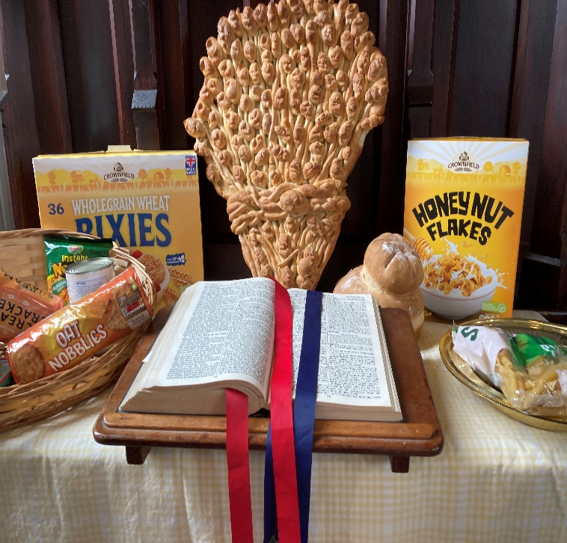

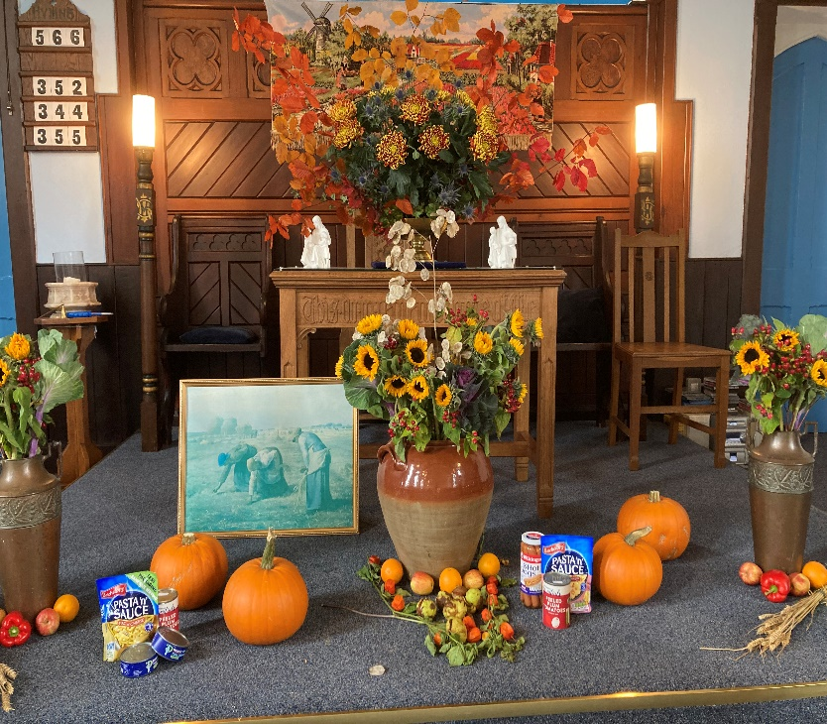

One of our congregation has come up with the wonderful idea of placing a nativity scene outside our Church and they and another member have been busy building a stable and the figures to go inside. Some of the ladies from our crafting group spent a day busy making and dressing the figures. So we look forward to seeing the nativity as Christmas approaches.
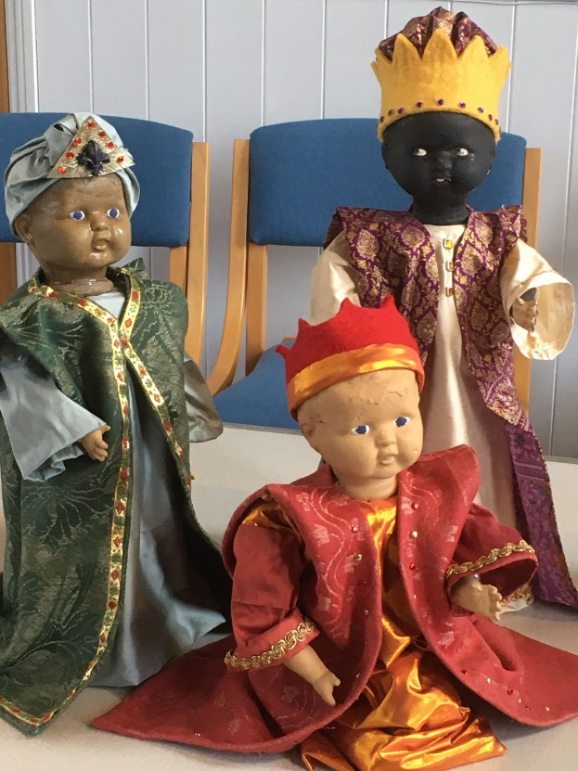
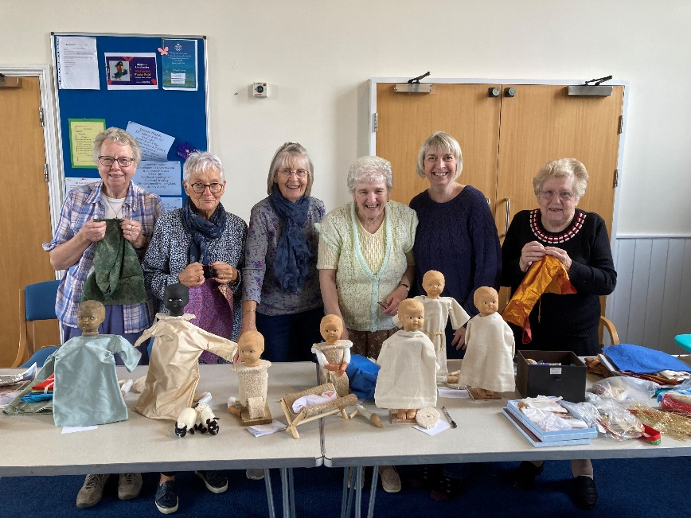

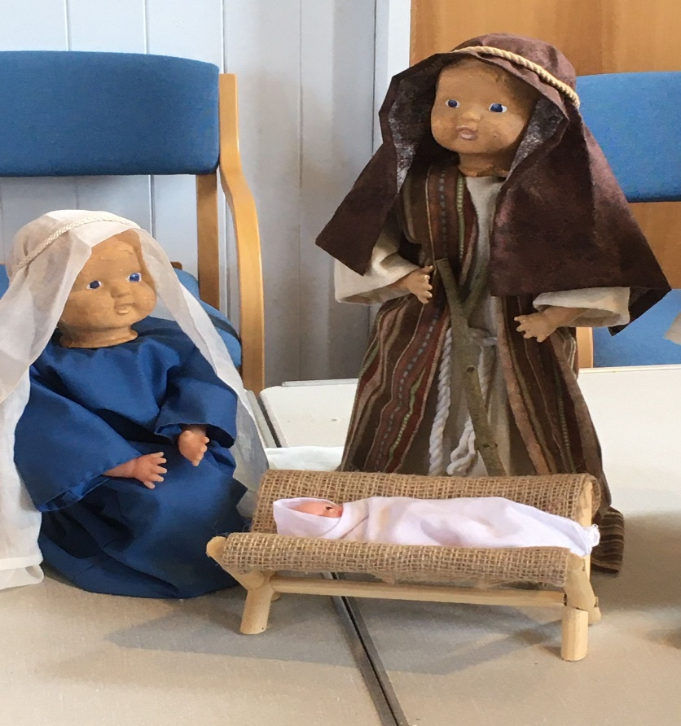

Because our Church is situated in easy walking distance of the War Memorial, we always host the United service on Remembrance Sunday. This year we decided to have a cascade of poppies outside our Church, with lots of poppies being knitted by our craft club ladies.

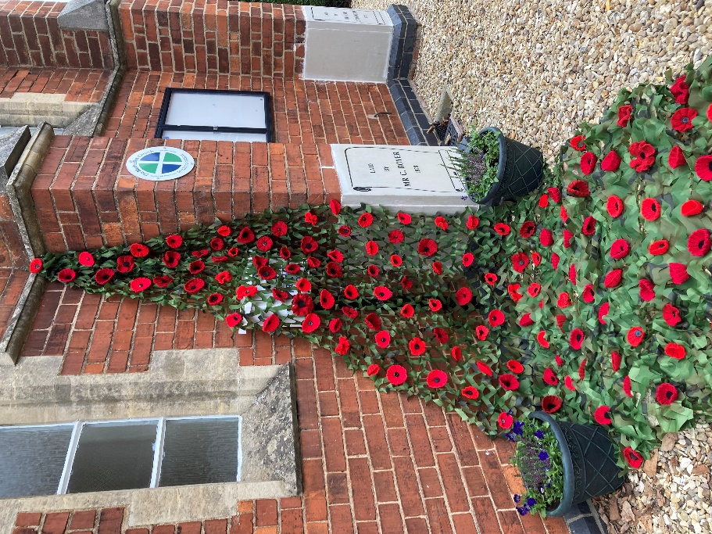

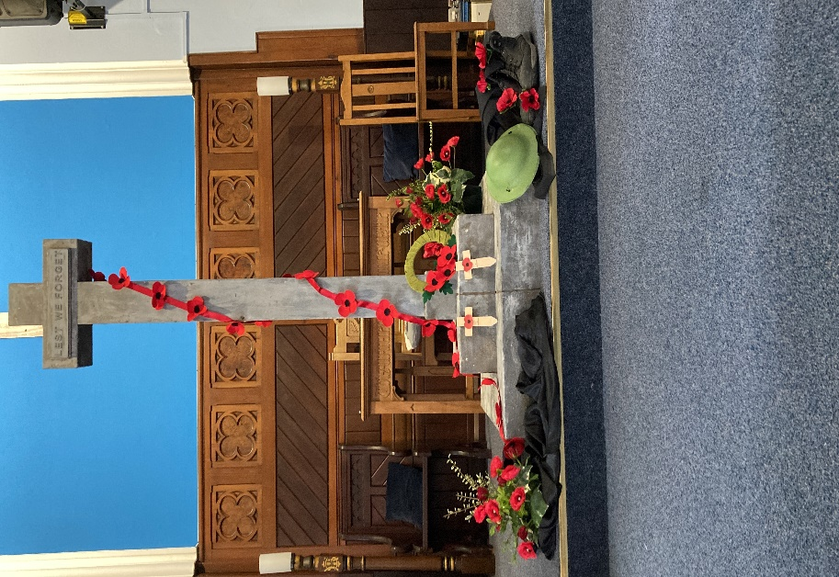

REGULAR EVENTS
Pop In - Every Thursday Morning 9.30am – 11.am
(but not last Thursday in the month)
PLEASE NOTE THAT OUR POP IN WILL BE HAVING A SHORT BREAK THE LAST ONE WILL BE ON THE 12th DEC AND WILL REOPEN ON THE 6th FEBRUARY WEATHER PERMITTING.
Emporium Sales 10am – 12.30pm
26th October
30th November this one will include cake stall, raffle, Christmas jigsaws and books.
28th December – We are planning to open up so people can come together for cake & carols the Emporium will be open too.
26th January
Light Lunches 11.30am – 1pm
12th November
10th December
14th January
You will find a warm welcome.
Craft afternoon – 2pm –4pm
18th November
16th December
20th January
Also jigsaws available to hire.

HOLBEACH NEWS
On Sunday September 15th we enjoyed our annual Harvest Festival Service. The Church was decorated for the occasion with all food donations going to the local Food Bank.

Libby led the lovely service, and everyone enjoyed the age old lesson of “what you sow you reap” which
left plenty of food for thought!!

Talking of food - after the service we had our usual coffee whilst the ladies were busy preparing a Ploughman’s lunch which was delicious and our thanks to Kelsay for leading this event. And thanks to Odile for our opening prayers. Typically, Rev Luke managed to pop in just as food was being served!!!

All donations from the lunch will go to the “All We Can” which is a Charity raising money to challenge global injustice and poverty.
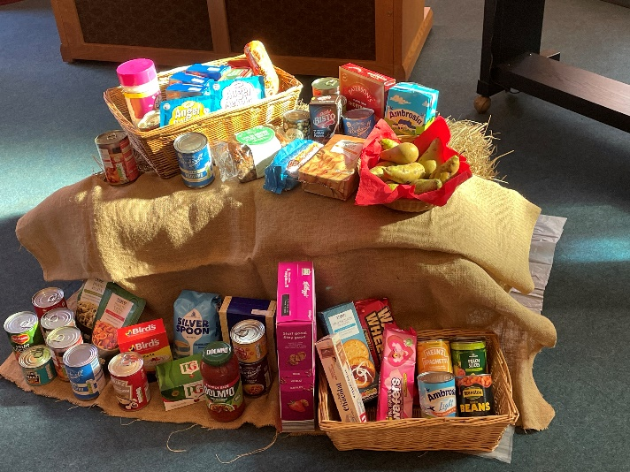
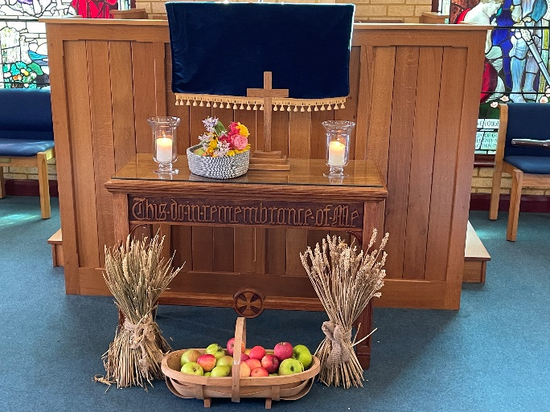
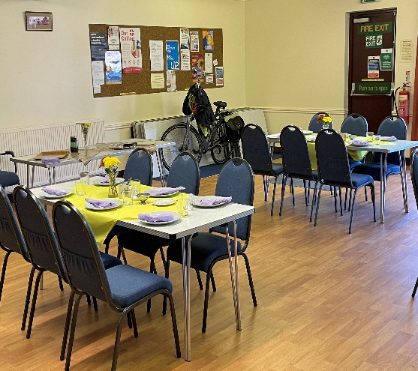

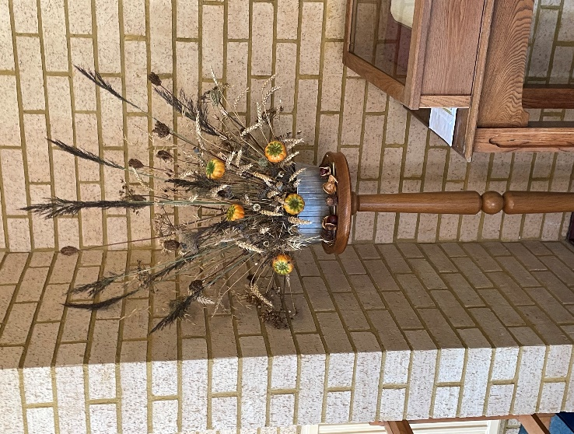
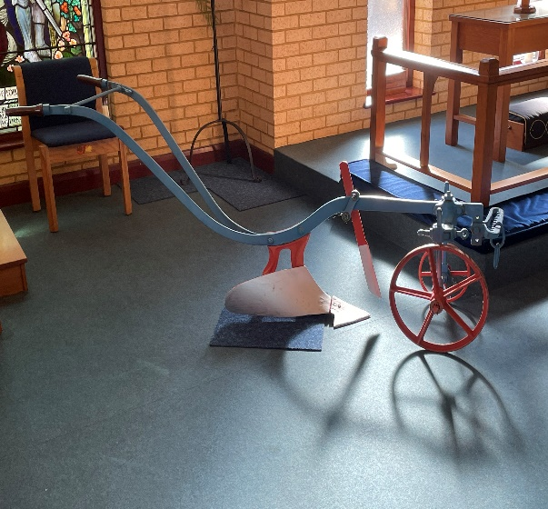

HOLBEACH METHODIST CHURCH
The Romans Course
Discover your place in God’s story as you explore the Letter to the
Romans with your small group or as a whole church.

We will be having bible study sessions over the late Summer and Autumn. We will be looking at Romans on a Wednesday afternoon at 2pm.
Wednesday 20th November Community – How can we live together in love?
Wednesday 4th December Mission – How can we be ambitious with the gospel?
For more information on the course material please go to:
www.biblesociety.org.uk/resources/the-romans-course
Come to all 10 or as many as you can. This course is open to all.

MOULTON CHAPEL
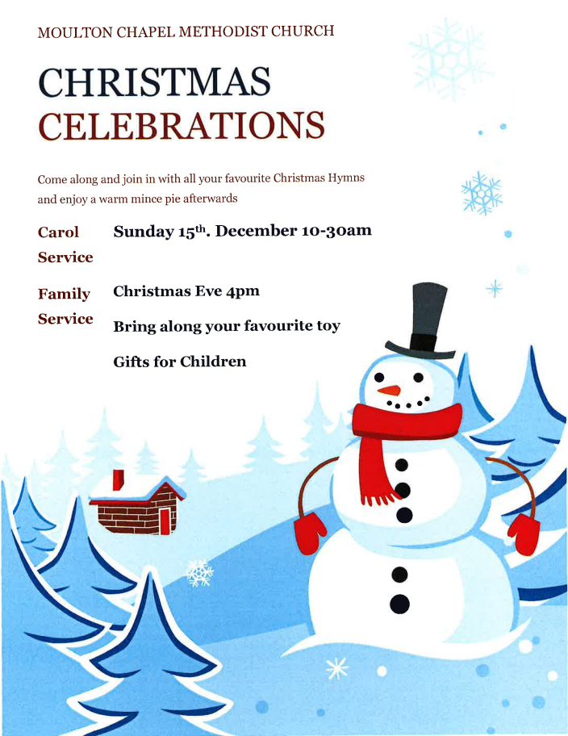
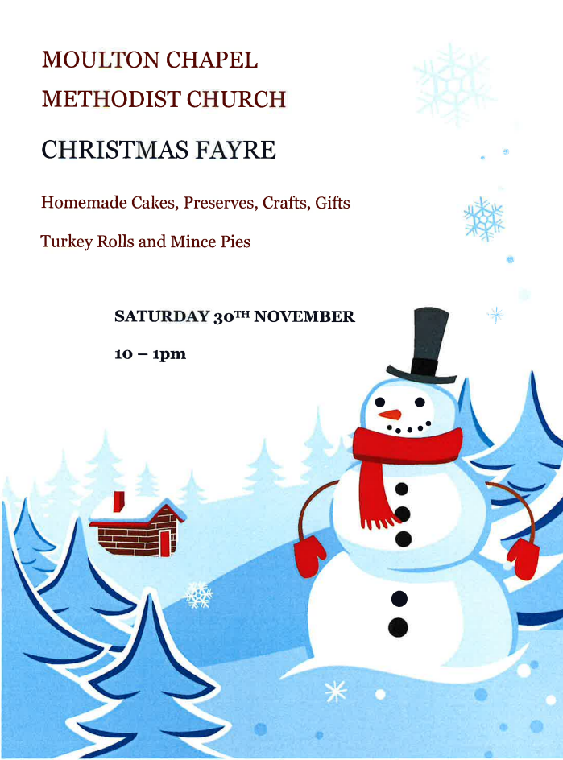

MOULTON CHAPEL METHODIST CHURCH
PLOUGH SERVICE
SUNDAY 12TH. JANUARY 2025
10-30AM
FOLLOWED BY LUNCH

SPALDING BROAD STREET NEWS
BROAD STREET PUMPKIN EVENT

We opened our doors for pumpkin activities and crafts on 12th October. This was at the same time as the Town’s Pumpkin Festival and the MWIB Coffee Morning in our Hall. Approximately 150 people, including almost 50 children, came through our doors to enjoy themselves. Some of the happy visitors are shown in the photos below.
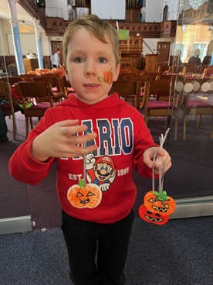

1st Spalding Brownies

In September we received a very warm welcome to run 1st Spalding Brownies in the hall at Broad Street. The pack has settled in well and love the new venue.
Since then we have been working towards a ‘Fish & Chip’ badge, by playing a ‘Hot Potato’ game, having a ‘potato and spoon’ race, and playing a version of Beetle Drive using Mr Potato Head instead (see our notice board for various attempts to create Mr Potato Head). The girls have also done a blind taste test for different flavour crisps.

We’ve celebrated Roald Dahl Day by making mini beasts and having paper caterpillar races. Add to that a pumpkin evening of craft to coincide with the local pumpkin parade as well as an outing to play ten pin bowling. All that just in the first half term!

During the second term the girls will have made, edible sparklers and smartie Catherine wheels, designed and written postcards to the front to mark Remembrance Day as well as taking part in the town’s Remembrance Parade.

It’s then on to the weeks leading up to Christmas and joining in with Broad Streets Christmas Tree Festival with the theme of Christmas Music. Our pack has chosen Chris Rea’s ‘Driving home for Christmas’, so come a long and see all the trees and join in the festivities.

Our term continues with Christmas craft and card making, with our final evening of the year being a Christmas party.

If you like the sound of what we do and are a girl aged 7-10 years old, or know of someone who may like to join us, we meet during term time on a Monday evening 5:15pm - 6:30pm. We currently have spaces, so please register your interest at

https://www.girlguiding.org.uk/ and use the ‘For Parents’ tab along the top.

We’d love to see you,

Cloud, Little Owl, and Blossom

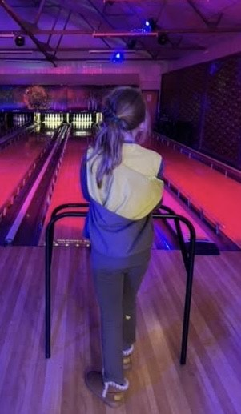

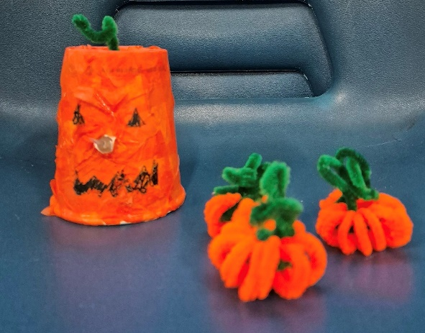

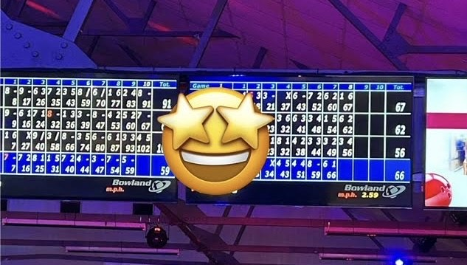
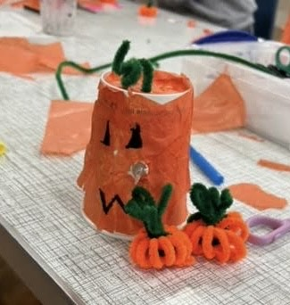

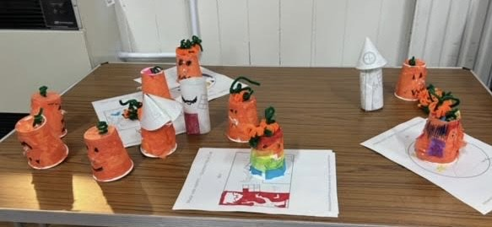

WELCOME SPACE
Welcome Space at Broad Street is thriving!
When we first opened as a Warm Space two years ago, we had just one person come and visit us. We opened as a space where people could come and keep warm and have a drink and chat. As time moved on, we began to see a need to offer free meals and now we regularly feed 40+ people each week and we hit just over 50 people at our Christmas Welcome Space. Our traditional meals of casseroles and roasts with crumbles or sponge puddings are very popular. Many look forward to visiting us as it is the first hot meal they have had in a while.
Sadly, we are thriving as more people are coming to us for the company because they are lonely, some because they are hungry and some come because they need someone to listen to them when life is difficult. We have supported several who are homeless. We regularly hear heart-breaking stories.
We have a Warm Rail which has been very well used over the winter and on many occasions supplies of coats, jumpers, scarves, gloves, sleeping bags and blankets have nearly run out. We also supply toiletries and sanitary items – again these items are needed by several of our regulars.
To fund this, we have received grants from the District and local councillors and our donation plate is always out on a Monday for those who feel they can contribute.
We have a core team of regular helpers, and I know from the comments of our visitors their work, support and listening ears are all very much appreciated. I am very grateful to all of our Monday volunteers some of whom are not members at Broad Street. We all work together well as a team to support some of the most vulnerable members of our community.
We hope to continue to run Welcome Space for as long as there is a need for it. As always, we are on the lookout for more people to join the team. If you think you are able to offer some time on a Monday to help (the washing up is mammoth!) with this then please get in touch with me. It could be you would like to help in the kitchen or be someone who can lend a listening ear to someone in need. I can talk you through what happens or you might like to pop along one Monday between 10am and 2pm to get a feel for what we do. Please note safer recruitment is required to be a volunteer on a Monday.
Sarah Ekins

BROAD STREET – CHRISTMAS 2024

Friday 29th November, 5.00 p.m. until 9.00 p.m. Come and view
the decorated trees. This year, decorators have been asked to pick
a favourite Christmas song and decorate to reflect their choice.

Saturday 30th November, 10.00 a.m. until 1.30 p.m. View the decorated trees, children’s activities and Christmas Fayre.
Sunday 1st December, 10.30 a.m. Christmas Tree Service. We will be using some of the songs chosen by our tree decorators in our worship.
Saturday 7th December, 10.00 a.m. until 1.30 p.m. View the decorated trees, children’s activities and Christmas Fayre.
Sunday 8th December, 9.00 a.m., Breakfast Fellowship, followed
by Christingle Service at 10.30 a.m.
Saturday 14th December, 7.00 p.m., Spalding Community Choir Christmas Concert.
Saturday 21st December, 3.00 p.m., Concert in aid of Alzheimer’s Society.
Sunday 22nd December, 10.30 a.m., The Shiny Bright Sparkling Light Pop-Up Nativity.
Christmas Eve, 24th December, 3.00 p.m., Family Christmas Celebration
Christmas Eve, 24th December, 7.00 p.m., Carol Service among
the decorated trees.
Christmas Day, 25th December, 10.00 a.m. Christmas Morning Worship.

WHAT’S ON AT BROAD STREET
Sunday: 9.00 a.m. Informal Worship, with Breakfast Fellowship the 2nd Sunday of each month.
10.30 a.m. Morning Service

Monday: Welcome Space - Hall 10.00 a.m. – 2.00 p.m. About 30-40+ people are regularly welcomed and fed, including some who are homeless. Chat is important for some who are lonely. A warm rail is used in the winter months. Helpers are caring for the guests in a friendly way in a safe space.
Tuesday: Coffee Morning - Hall 10.00 a.m. – noon
Shoppers’ Service - Church 10.45 a.m. – 11.00 a.m. The popular get-together of members and friends with a time for worship too.
1st and 3rd Wednesday of each month: Midweekers 7.00 p.m. - 9.00 p.m. A meeting which enjoys a varied program of devotional and participation activities, as well as guest speakers. There is an occasional afternoon outing.
2nd Wednesday of each month Luncheon Club, noon - 2.00 p.m. A 3-course meal for a donation of £6. Booking essential. Good company for those who attend.
4th Wednesday of each month: Four Seasons, 2.00 p.m. - 4.00 p.m. About 20 people come along to play dominoes, scrabble and more recently cribbage. Many of the people who come live on their own and they enjoy the company, friendship, chatter and laughter. We do have fun. If you’d like to come along, you’d be very welcome. We have tea or coffee, biscuits and /or cake and we go out for lunch two or three times a year. You don’t have to be an expert at the games, just come along for a chat and a drink.
Thursday: Family Play 1.00 p.m. – 3.00 p.m. For babies and pre-school children in the lovely Church and lounge area. Older siblings came during the school holiday in May.
1st Thursday of each month: Prayer Meeting, 6.00 p.m. -7.00 p.m. All welcome, your presence is all that is needed, prayers can be silent, read out, or spontaneous.
Friday: Knit and Natter 10.00 a.m. - noon. A group busy providing articles of clothing and blankets for those in dire need in Armenia. An invitation to just come along for a chat if you can’t knit or crochet.
3rd Saturday of each month: Messy Church. For all ages, run by our Youth and Community worker to include various activities with a Bible basis.

Al-Anon Family Groups UK & Eire offers support for anyone whose life is or has been affected by someone else’s drinking.
Members are all kinds of people from all walks of life: partners, sisters, brothers, sons, daughters, fathers, mothers, friends and children of problem drinkers.
Group meetings are confidential. We protect individuals’ anonymity by using first names only. Neither attendance nor the content of what anyone shares in a meeting will be revealed outside of the group.
Spalding group meet every Monday from 8pm to 9.30pm in the Fellowship room at Broad Street Methodist Church. There is always a warm welcome, tea, coffee and biscuits. There is no charge and no need to book, just come along. Al-Anon is funded solely through members’ own voluntary donations. You need to be aged 18 or over to attend this group, but there are some groups available just for 12 – 17 year olds.
There is lots more information on the website www.al-anonuk.org.uk or via the helpline 0800 0086 811




Alcoholics Anonymous Spalding
Meeting held at Broad Street Methodist Church
Every Monday 20:00 - 21:30 including Bank Holidays
Alcoholics Anonymous is a voluntary, worldwide fellowship of men and women from all walks of life who meet together to attain and maintain sobriety. The only requirement for membership is a desire to stop drinking. There are no dues or fees for A.A. membership.

SUTTERTON NEWS

We continue to hold joint services with Kirton on the third Sunday of the month. One month they come to us and the next we go to them. We have forged a good friendship with them over the last few years.
We hold a Coffee Morning on the first and third Wednesday of the month, these are well supported by the local people.
Our Harvest Tea was held on the 12th October. We prepared a Ham Salad and Jacket Potato and a dessert. We had a nice afternoon meeting up with friends over a meal. The following day we had our Harvest Festival service which was taken by Darren Charlton.
On Tuesday 15th October we hosted the Local Preachers and Worship Leaders reaffirming service. Bob Bartindale, the Ministry Development Officer (Worship and Local Preachers) came in the afternoon and there was a discussion about own arrangements. Then in the evening there was a service where the local preachers and worship leaders reaffirmed their vows. Revd. Luke Smith took the communion service and Bob Bartindale took the sermon.
We are looking forward to the Salvation Army coming once again on Saturday 13th December. The service starts at 6 p.m. We sing carols with them and it is a very enjoyable evening. Light refreshments will be available after the service.
There are not many of us at Sutterton but we seek to keep the Church open for the community. All the support we get from the Circuit and locally is very much appreciated and we would like to say Thank You.

SUTTERTON WHAT’S ON

Coffee Morning 1st and 3rd Wednesday in the month –
10 a.m. to 12 noon

13th December - Salvation Army at 6 p.m.
Followed by light refreshments.

22nd December – Carol Service at 10.30 a.m.
Led by Darren Charlton

24th December – Christmas Eve Service at 3 p.m.
Led by Revd. Luke Smith

PLAN OF SERVICES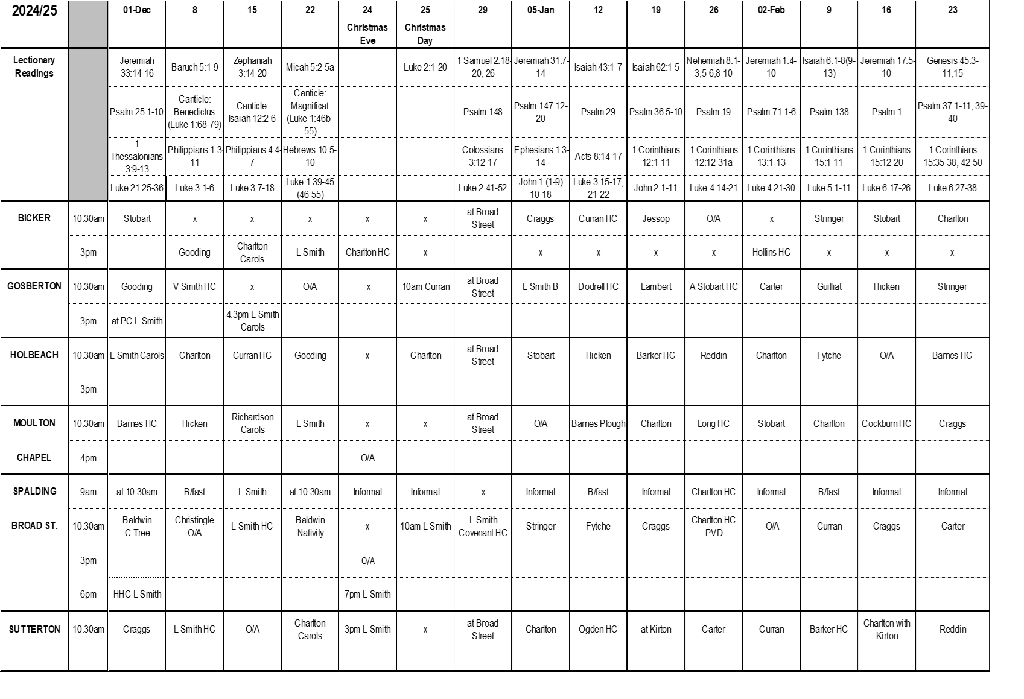
UPCOMING EVENTS

Sunday 24th November – Bicker, Church Anniversary 3.00 p.m. (Followed by tea)

Friday 29th November – Broad Street view the Christmas Trees 5.00 p.m. – 9.00 p.m.

Friday 29th November – Holbeach Town Band 7.00 p.m.

Saturday 30th November – Broad Street Christmas Fayre with Children activities 10.00 a.m. – 1.30 p.m.

Saturday 30th November – Gosberton Emporium 10.00 a.m. – 12.30 a.m.

Saturday 30th November – Moulton Chapel Christmas Fayre 10.00 a.m. – 1.00 p.m.

Sunday 1st December – Broad Street Christmas Tree Service 10.30 a.m.

Saturday 7th December – Broad Street Christmas Fayre with Children activities 10.00 a.m. – 1.30 p.m.

Sunday 8th December – Broad Street Breakfast Fellowship 9.00 a.m.
- Christingle Service 10.30 a.m.

Thursday 12th December – Holbeach Christmas Fayre & blessing the trees 9.30 a.m. with service at 10.45 a.m.

Friday 13th December – Sutterton, Salvation Army, 6.00 p.m.

Saturday 14th December – Broad Street, Spalding Community Choir Christmas Concert 7.00 p.m.

Sunday 15th December – Bicker, Carol Service 3.00 p.m. (Followed by mince pies and hot drinks)

Sunday 15th December – Moulton Chapel Carol Service 10.30 a.m.

Saturday 15th December – Gosberton Carol Service 4.30 p.m.

Saturday 21st December – Broad Street, Concert in aid of Alzheimer’s Society 3.00 p.m.

Sunday 22nd December – Broad Street, The Shiny Bright Sparkling Light Pop-Up Nativity 10.30 a.m.

Sunday 22nd December – Gosberton Carol Service 10.30 a.m.

Sunday 22nd December – Sutterton Carol Service 10.30 a.m.

Christmas Eve, Tuesday 24th December – Bicker, Communion Service 3.00 p.m.

Christmas Eve, Tuesday 24th December – Broad Street Family Christmas Celebration 3.00 p.m.

Christmas Eve, Tuesday 24th December – Sutterton Christmas Eve Service 3.00 p.m.

Christmas Eve, Tuesday 24th December – Moulton Chapel Family Service 4.00 p.m.

Christmas Eve, Tuesday 24th December – Broad Street Carol Service 7.00 p.m.

Christmas Day, Wednesday 25th December – Christmas Morning Worship 10.00 a.m.

Saturday 28th December – Gosberton Emporium Carols 10.00 a.m. – 12.30 p.m.

Sunday 12th January – Moulton Chapel Plough Service 10.30 a.m. (Followed by lunch)



I really do enjoy creating the newsletter for you all to read, so please can you carry on sending you items into me. I know it can be a struggle to think what to add, but anything which has happened please let us know, you can send photos we really do not mind.

If there are any articles or photos you wish to submit for the 1st quarter newsletter 2025 please send them to office via email or hand to Luke or Darren. To reach me no later than 12/01/2025.

